Thymele Arts - Kansas Room Tech Rider

Room Size: 14’ x 40’

Lighting
- Front Light
  - Stage Right
  - Stage Left
- DMX Channels: 12 or 6
- DMX Connectors: 3-pin XLR
- Light Source: 4 LEDs (quad-color) 3.5 W, (1.5 A) SlimPAR Q12 BT
  - Beam Angle: 17°
  - Field Angle: 35°
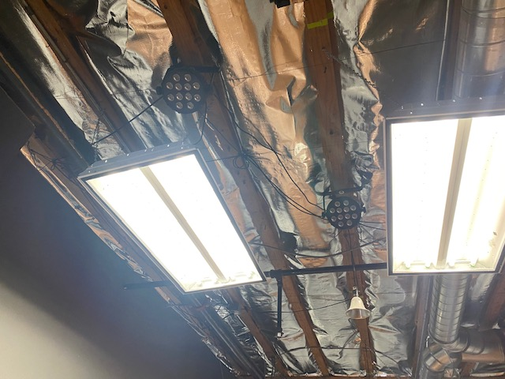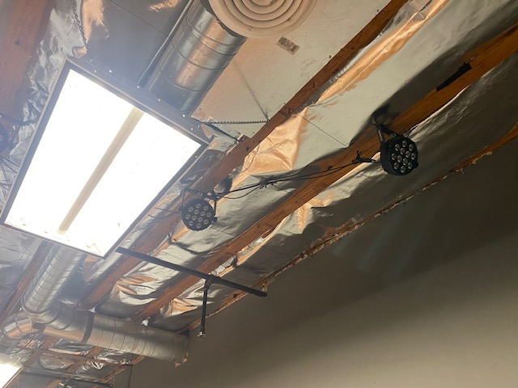
- Control
  - 2 - Elation Pro 12 Channel DMX LX Board
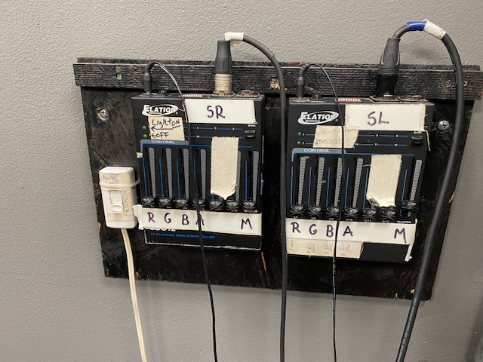

Furniture
- Chairs (30)
- Rehearsal Blocks (available upon request)
- 4’ x 4’ Wooden Table (1)

Dressing Room
- There is a small closet in the room that can be used as a playing space or a dressing room. It includes a dressing table, clothing rack, and a full length mirror.

** There is Storage available upon request for an additional fee.

DO NOT PUT HOLES IN WALL OR CEILING JOISTS

